

**Computer Science & Engineering**

CSE2006 – Microprocessor and Interfacing

**LAB FAT**

Submitted to **Prof. SANJAY R**

NAME: PUNIT MIDDHA

REG.NO: 19BCE2060

SLOT: L43+L44

DATE: 08/12/2021

Write the ALP to arrange a given series of hexadecimal bytes in ascending order. Assume the array of decimal numbers as16, 27, 13, −23, −18, 10

**AIM:**

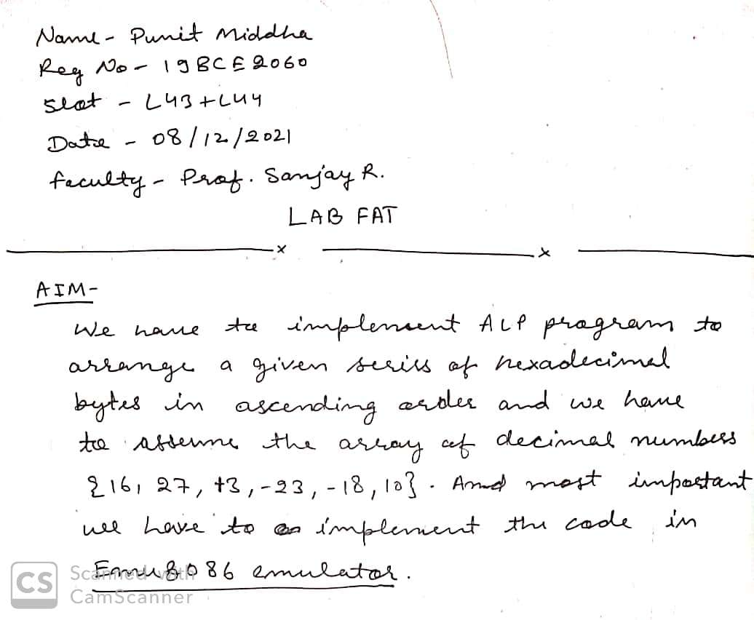

**ALGORITHM:**

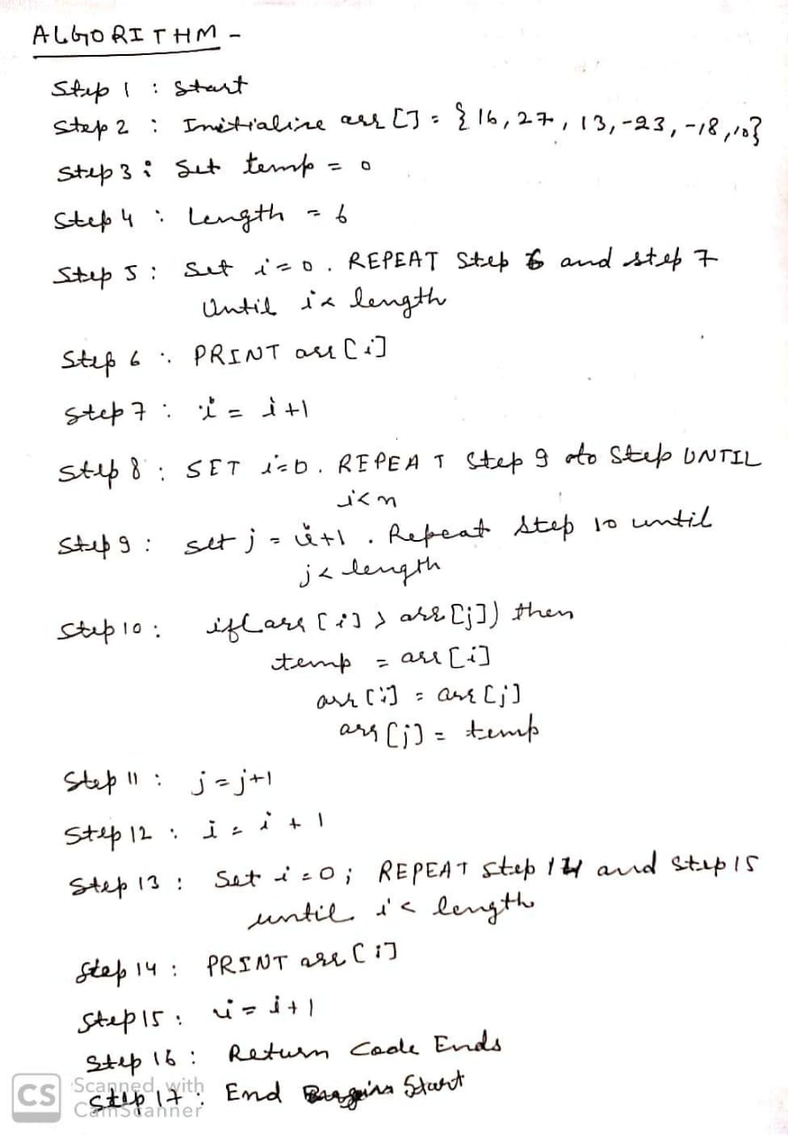

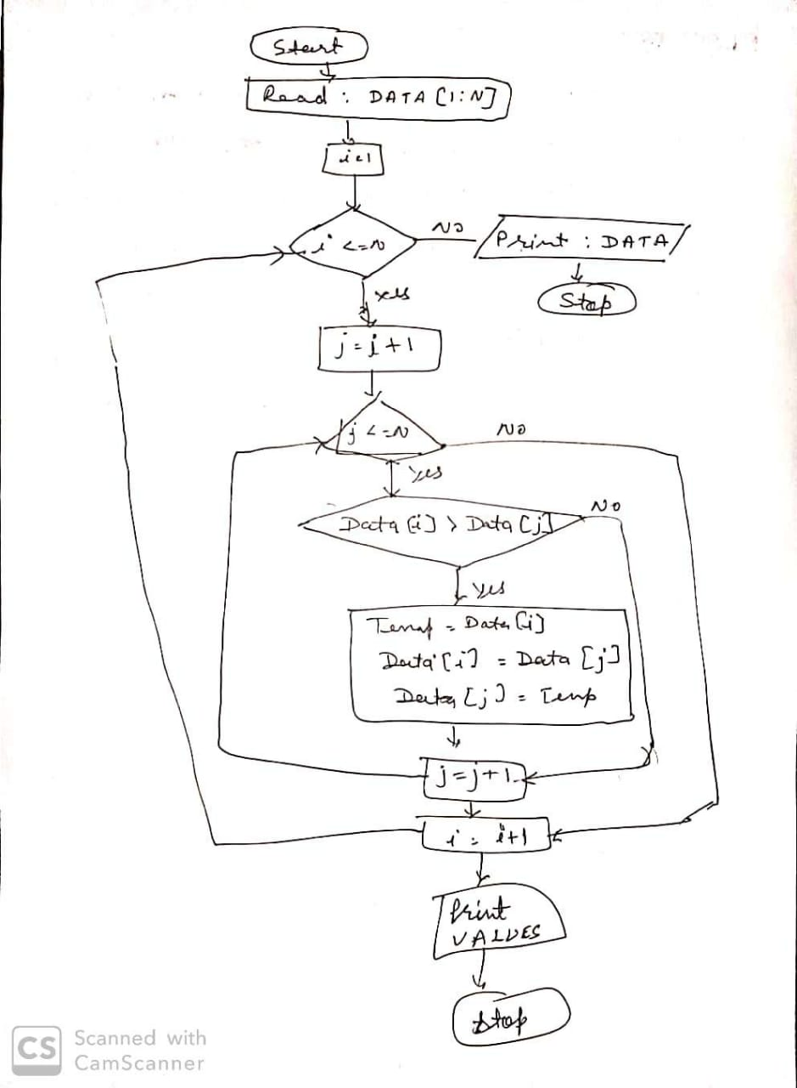

**ALP PROGRAM:**

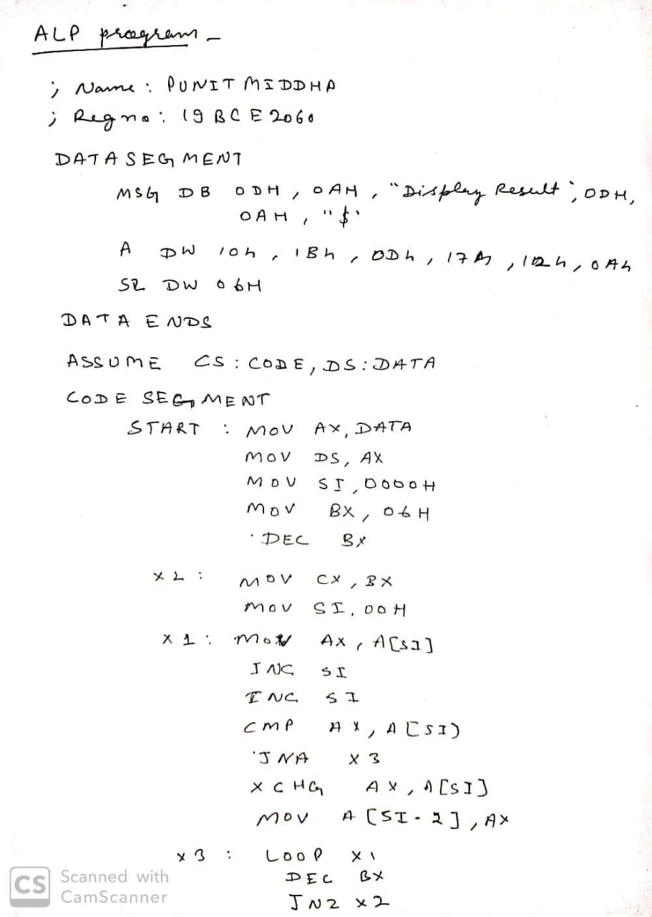

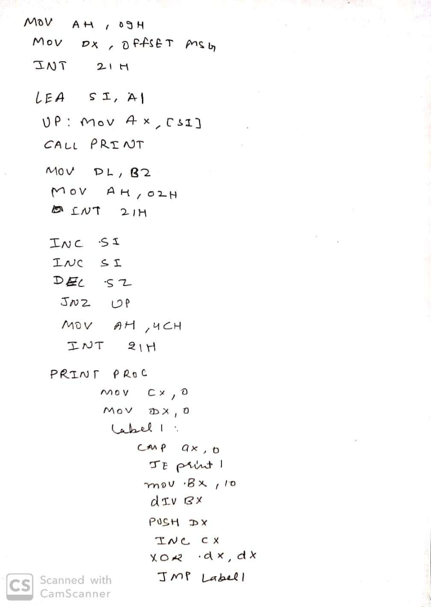

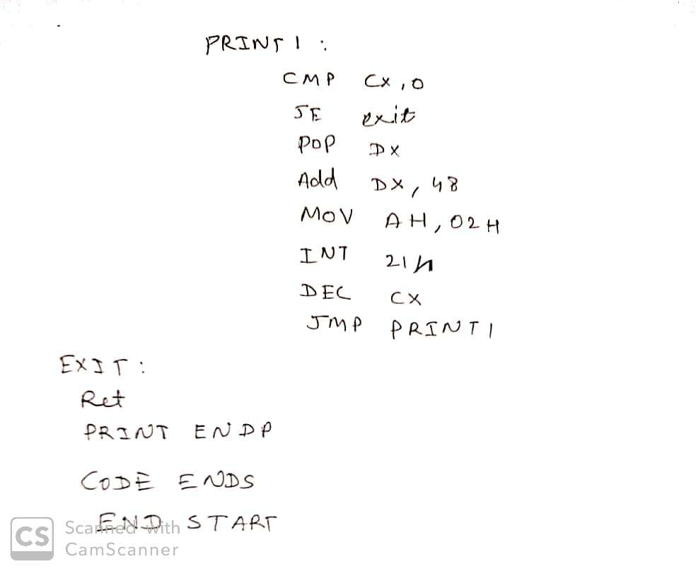

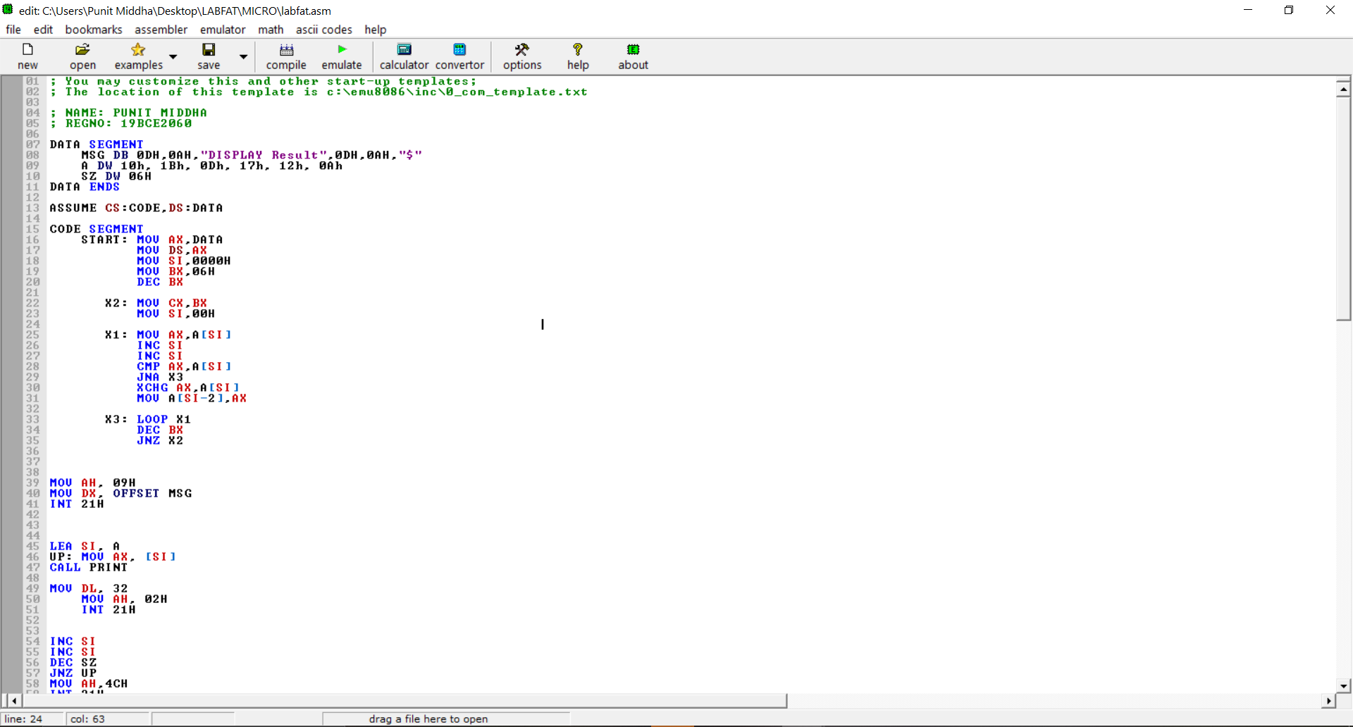

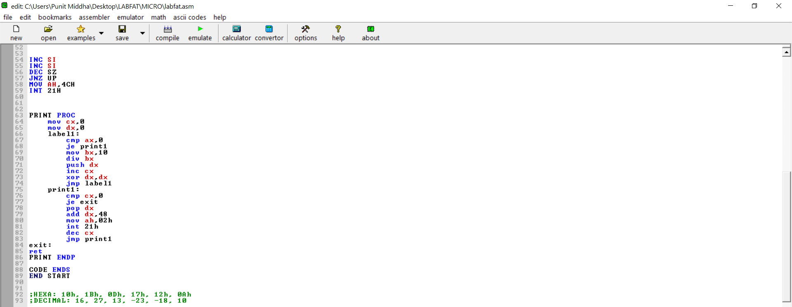

**IMPLEMENTATION:**

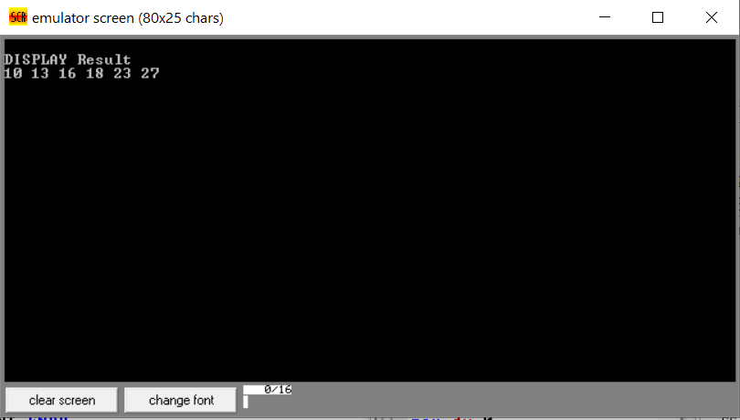 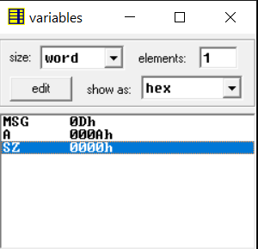

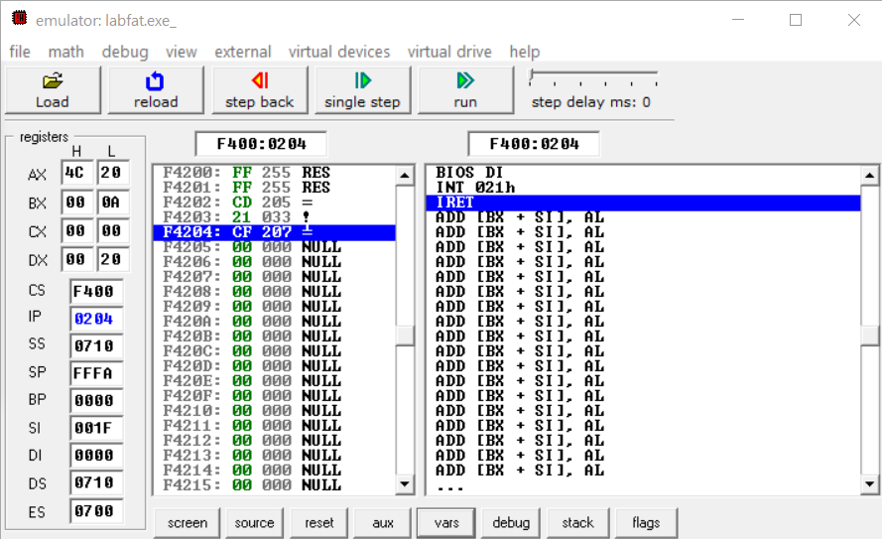

**RESULTS:**

